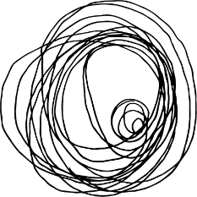

Snacks
Gordal Olives / House Blend Olives / Valencian Almonds / Pickled Guindilla Peppers £3.5
Plattsville Sourdough, Jersey Butter £3.5
Rosemary Focaccia, Extra Virgin Olive Oil £3.5
Hummus, Chilli Oil, Plattsville Sourdough £4.5
Small
Soup Of The Day, Plattsville Sourdough £5.5
Vegetable Tempura, Honey, Thyme £6
Sliced Speck, Cornichons £5.5
Smoked Haddock Rarebit, Apple, Pickled Shallots £9
Burnt Leeks, Gordal Olive, Dukka, Dill £7.5
Larger
Roasted Squash, Courgette, Chickpeas, Shallot Vinaigrette £10
Harissa Buttered Chicken, Braised Leg, Sweetcorn, Chimichurri £13
Pork Chop, Apple, Kohlrabi, Bitter Leaves £17
Monkfish, Coriander Lime Chilli Broth, Pak Choi, Sugar Snaps £15
Sea Trout, Salt Baked Beetroot, Beetroot Emulsion, Fennel, Nasturtium £14
Sides
Chips, Aioli £4
Caramelised Onion Potato Gratin £5
New Potatoes, Anchovy Garlic Butter £4
Tenderstem Broccoli, Almonds, Pink Peppercorn £4
Savoy Cabbage, Mustard Cream £4
Sweets
Cherry Cake, Cherry Sorbet, Pistachio £6
Poached Plums, Cream Cheese, Almond Praline £6
Set Chocolate, Coffee Sabayon, Roasted Figs £6
Homemade Ice Cream - Ask Your Server For Flavours £1.5 / £4

